4.STATIC SYNCHRONOUS SERIES COMPENSATOR
4.1. Introduction
In this chapter addresses the problem of controlling and modulating power flow in a transmission line using a Synchronous Static Series Compensator (SSSC). The simulation studies, which include detailed representations of twelve-pulse and PWM controlled SSSC, are conducted and the control circuits are designed. The developed control strategies for both twelve-pulse and PWM-controlled SSSC use direct manipulations of control variables instead of typical d-q transformations, which further simplifies the control circuits.
The STATCOM and UPFC operating principles and control circuit design are the SSSC operating characteristics, particularly with regards to control circuits design. This thesis explains in detail the SSSC operation and control circuit design process, which should be beneficial for future research work. For example, the PWM-controlled SSSC presented in this thesis is not properly documented in the literature, even though the idea itself is not new. Again, the developed SSSC models, as in the case of the STATCOM models are unique, since the implementation is not an easy task. Furthermore, the models developed are included into a realistic test system. The presented detailed models of the SSSC are particularly useful in control and protection circuits design, as these realistically reproduce the controller response in a power system.
In section, 4.2 discuss the basic operating principle, 4.3 discuss the functional model of SSSC, in section 4.4 discuss the series compensation by SSSC, in section 4.5 discuss the distributed power flow controller, in section 4.6 discuss the DPFC operating principle, in section 4.7 discuss the using third harmonic components, in section 4.8 discuss the DPFC control, in section 4.9 discuss the central control, in section 4.10 discuss the advantages and limitation of the DPFC, in section 4.11 advantages and limitation of the DPFC.
4.2. Basic Operaing Principle
The SSSC controller consists of a solid-state VSC with several GTO thyristor switches or any other semiconductor switches with intrinsic turn-off capability valves, a dc capacitor a transformer, and a controller. It is important to note that several of the VSCs can be connected together through a transformer of sometimes a complex and custom made design configuration. The number of valves and the various configurations of the transformer depend on the desired quality of ac waveforms generated by the SSSC. Another approach involves PWM-controlled VSCs where the quality of the ac output waveforms depends on the switching frequency.
The line side transformer winding is connected in series, placing the VSC also effectively in series with a transmission line, and thus allowing series compensation of the line. The SSSC is used to generate or absorb reactive power from the line, and hence can be utilized as a transmission line power flow controller. Basically, it generates on its output terminals a quasi-sinusoidal voltage of variable magnitude in quadrature with the transmission line current, if the SSSC losses are neglected. Thus, the line injected voltage emulates a capacitive or an inductive reactance in series with a transmission line, which increases or decreases the total transmission line reactance, resulting in a decrease or increase of the power flow in the transmission line.
In general, the SSSC can be viewed as analogous to an ideal synchronous voltage source as it can produce a set of three-phase ac voltages at the desired fundamental frequency of variable and controllable amplitude and phase angle. It also resembles a synchronous compensator, as it can generate or absorb reactive power from a power system and can, independently from the reactive power, generate or absorb real power if an energy storage device instead of the dc capacitor is used in the SSSC.
The SSSC is typically restricted to only reactive power exchange with the nearby ac system, neglecting the small amount of real power used to cover the circuit and switching 96 losses, because of the relatively small SSSC capacitor. If the dc capacitor were replaced with an energy storage system, the controller would be able to exchange real power with the ac system and compensate for the transmission line resistance. Alternatively, a STATCOM could send real power to the SSSC through a common dc capacitor. The combined controller formed by this connection is called a Unified Power Flow Controller (UPFC), as explained in more detail in figure shows a functional model of the SSSC where the dc capacitor has been replaced by an energy storage device such as a high energy battery installation to allow active as well as reactive power exchanges with the ac system. The SSSC’s output voltage magnitude and phase angle can be varied in a controlled manner to influence power flows in a transmission line. The phase displacement of the inserted voltage V_{pq}, with respect to the transmission line current I_{line}, determines the exchange of real and reactive power with the ac system.
4.3. Functional Model Of SSSC
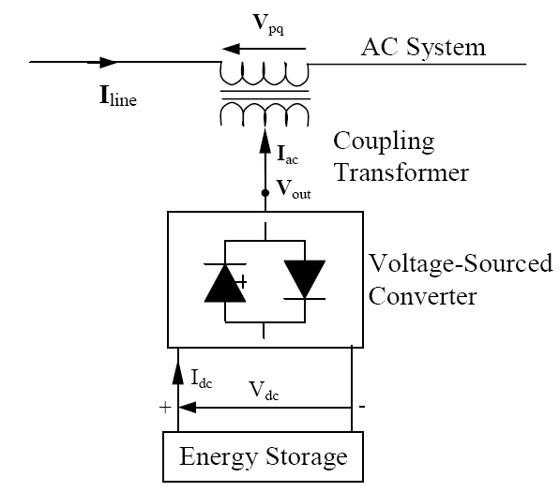
Fig.4.1. Functional model of SSSC
The fig 4.1 shows the SSSC operation in four quadrants, again assuming an energy storage device connected at the SSSC’s input terminals. The line current phasor I_{line} is used as a reference phasor while the injected SSSC voltage phasor is allowed to rotate around the centre of the circle defined by the maximum inserted voltage max Vpq. Theoretically, SSSC operation in each of the four quadrants is possible.
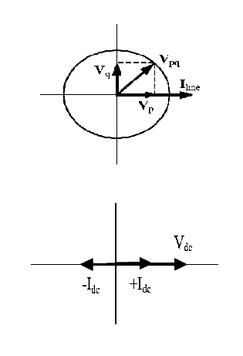
Fig.4.2. SSSC phasor diagram
In capacitive mode, the injected SSSC voltage is made to lag the transmission line current by 900 in this case, the SSSC operation is similar to the operation of a series capacitor with variable capacitance kX_{c}, i.e., V_{pq} = −jkX_{c}I_{line} , where k is a variable. By this action, the total transmission line reactance is reduced while the voltage across the impedance is increased, leading to increase in the line currents and transmitted power.
It is also possible to reverse the injected SSSC voltage by 1800, i.e., V_{pq} = jkX_{c}I_{line} causing an increase in the transmission line reactance, which results in a decrease of the line current and transmitted power. While this equation for V_{pq} shows changes in the phasor magnitude and phase angle, it can be somewhat misleading, since it shows that the series injected voltage magnitude is directly proportional to the line current magnitude. In reality, this is not true; the inserted voltage magnitude is set by the SSSC control and is independent of the network impedance and, consequently, line current changes. It is assumed that the SSSC losses are zero and, therefore, the series injected voltage is in perfect quadrature with the line current, leading or lagging.
The operating conditions that limit the SSSC operation from the power system point of view are also depicted in Figure 4.3. The SSSC can increase as well as decrease the power flow in the transmission line by simply reversing the operation from capacitive to inductive mode. In the inductive mode, the series injected voltage is in phase with the voltage drop developed across the line reactance; thus, the series compensation has the same effect as increasing the line reactance. If the series inserted voltage magnitude is larger than voltage drop across the uncompensated line, i.e., V_{pq} ≥ V_{Line}, the power flow will reverse. This fact can limit the SSSC operation to values of V_{pq} ≤ V_{Line}, as in practice, it would be unlikely to use the SSSC for power reversal.
Also, if the rating of the SSSC controller is high, it is possible to increase or decrease the receiving end voltage above or below the typical operating voltage range of 0.9 p.u to 1.05p.u, but with possible negative consequences for other system devices. The SSSC output current corresponds to the transmission line current, which is affected by power system impedance, loading and voltage profile, as well as by the actions of the SSSC. Thus, the relationship between the SSSC and the line current is complex.
The fundamental component of the SSSC output voltage magnitude is, on the other hand, directly related to the dc voltage that is either constant or kept within certain limits, depending on the chosen design and control of the SSSC.

4.4. Series Compensation By SSSC

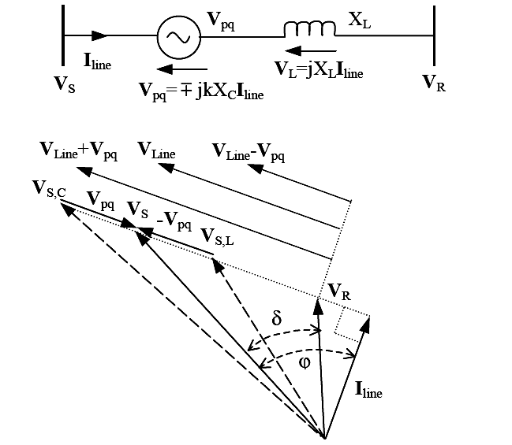
Fig.4.3. Series compensation by SSSC
The SSSC output voltage phase angle is correlated to the line current phase angle by plus or minus few degrees for example, to account for changes in the dc voltage. It has to be noted that the injected SSSC voltage Vpq is different from the SSSC output voltage VSSSC, due to the voltage drop or rise across the series transformer reactance, i.e.
V_{pq} = V_{sssc} m X_{tr}I_{line} … (4.1)

Where the minus sign corresponds to capacitive operation, while the positive sign corresponds to inductive operation of the SSSC and X_{tr} stands for the series transformer reactance. This voltage difference between the injected and output SSSC voltage can be small in the case of small transmission line currents, but it can be significant in high loading conditions. The active and reactive power exchanged between the SSSC and the transmission line can be calculated as follows:

P_{pq} = V_{pq}. I_{line} cos ø … (4.2)

Q_{pq} = V_{pq}. I_{line} sin ø … (4.3)
Where ø represents the angle between the injected SSSC voltage and transmission line current.
Inspection of the equations (4.2) and (4.3), considering that the angle between the SSSC output voltage and line current is approximately 900, shows that the SSSC real power should be small compared to the reactive power. This is expected, since the real power going into the SSSC is used only to cover for the losses and charging of the dc capacitor, i.e.,
P_{pq} = P_{dc} + P_{losses} … (4.4)
The losses in the SSSC circuit are due to the transformer windings and especially due to the switching of the GTO valves.
4.5. Distributed Power Flow Controller
Because of high control capability, the PE-based combined PFCs, specifically UPFC and IPFC are suitable for the future power system. However, the UPFC and IPFC are not widely applied in practice, due to their high cost and the susceptibility to failures. Generally, the reliability can be improved by reducing the number of components. However, this is not possible due to the complex topology of the UPFC and IPFC.
To reduce the failure rate of the components by selecting components with higher ratings than necessary or employing redundancy at the component or system levels are also options. Unfortunately, these solutions increase the initial investment necessary, negating any cost related advantages. Accordingly, new approaches are needed in order to increase reliability and reduce cost of the UPFC and IPFC at the same time. After studying the failure mode of the combined FACTS devices, it is found that a common DC link between converters reduces the reliability of a device, because a failure in one converter will pervade the whole device though the DC link. By eliminating this DC link, the converters within the FACTS devices are operated independently, thereby increasing their reliability.
The elimination of the common DC link also allows the DSSC to series converters. In that case, the reliability of the new device is further improved due to the redundancy provided by the distributed series converters. In addition, series converter distribution reduces cost because no high-voltage isolation and high power rating components are required at the series part. By applying the two approaches eliminating the common DC link and distributing the series converter, the UPFC is further developed into a new combined FACTS device the Distributed Power Flow Controller (DPFC).
In this chapter, the principle of the DPFC is presented, followed by a steady-state analysis of the DPFC. During the analysis, the control capability and the influence of the DPFC on the network are investigated. The principle and analysis of another device that emerges from the IPFC, the so-called Distributed Interline Power Flow Controller (DIPFC), is also introduced.

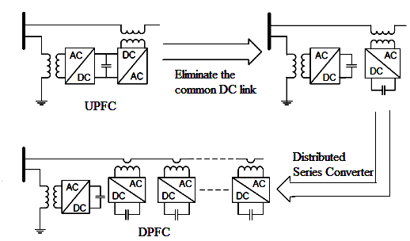
Fig.4.4. Flowchart from UPFC to DPFC

4.6. Distributed Power Flow Controller (DPFC)
In this section, DPFC topology and operating principle are introduced.
4.6.1. DPFC Topology
By introducing the two approaches outlined in the previous section into the UPFC, the DPFC is achieved. Similar as the UPFC, the DPFC consists of shunt and series connected converters. The shunt converter is similar as a STATCOM, while the series converter employs the DSSC concept, which is to use multiple single-phase converters instead of one three-phase converter. Each converter within the DPFC is independent and has its own DC capacitor to provide the required DC voltage.
As shown, besides the key components shunt and series converters, a DPFC also requires a high pass filter that is shunt connected to the other side of the transmission line and a Y-∆ transformer on each side of the line. The reason for these extra components will be explained later. The unique control capability of the UPFC is given by the back-to-back connection between the shunt and series converters, which allows the active power to freely exchange.
To ensure the DPFC has the same control capability as the UPFC, a method that allows active power exchange between converters with an eliminated DC link is required. The configuration of the DPFC.
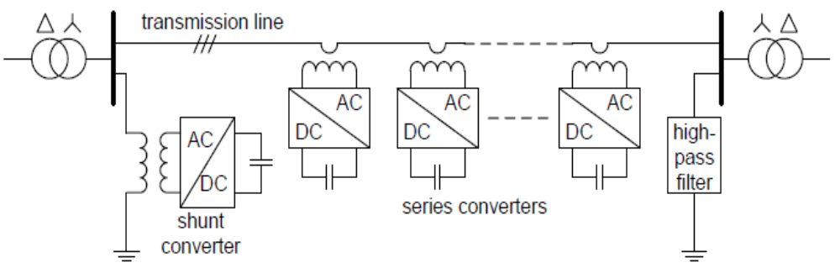
Fig.4.5. DPFC configuration
4.7. DPFC Operating Principle
Within the DPFC, the transmission line presents a common connection between the AC ports of the shunt and the series converters. Therefore, it is possible to exchange active power through the AC ports. The method is based on power theory of non-sinusoidal components. According to the Fourier analysis, non-sinusoidal voltage and current can be expressed as the sum of sinusoidal functions in different frequencies with different amplitudes. The active power resulting from this non-sinusoidal voltage and current is defined as the mean value of the product of voltage and current. Since the integrals of all the cross product of terms with different frequencies are zero, the active power can be expressed by
P = VI COS ϕ … (4.5)
Where V_{i} and I_{i} are the voltage and current respectively, and is the corresponding angle between the voltage and current. Equation shows that the active powers at different frequencies are independent from each other and the voltage or current at one frequency has no influence on the active power at other frequencies.
The independence of the active power at different frequencies gives the possibility that a converter without a power source can generate active power at one frequency and absorb this power from other frequencies.
4.8. Using Third Harmonic Components
Due to the unique features of 3rd harmonic frequency components in a three-phase system, the 3rd harmonic is selected for active power exchange in the DPFC. In a three-phase system, the 3rd harmonic in each phase is identical, which means they are ‘zero-sequence’ components.
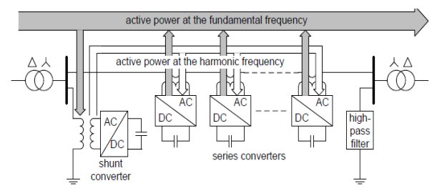
Fig.4.6. Active power exchange between DPFC converters
Because the zero-sequence harmonic can be naturally blocked by Y-∆ transformers and these are widely incorporated in power systems, there is no extra filter required to prevent harmonic leakage. As introduced above, a high-pass filter is required to make a closed loop for the harmonic current and the cutoff frequency of this filter is approximately the fundamental frequency. Because the voltage isolation is high and the harmonic frequency is close to the cutoff frequency, the filter will be costly. By using the zero-sequence harmonic, the costly filter can be replaced by a cable that connects the neutral point of the Y-∆ transformer on the right side in Figure 4.6 with the ground.
Because the ∆-winding appears open-circuit to the 3rd harmonic current, all harmonic current will flow through the Y-winding and concentrate to the grounding cable as shown in Figure 4.7. Therefore, the large high-pass filter is eliminated.
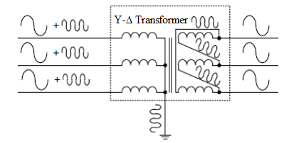
Fig.4.7. Utilize grounded Y-∆ transformer to filter zero-sequence harmonic
Another advantage of using the 3rd harmonic to exchange active power is that the grounding of the Y-∆ transformers can be used to route the harmonic current in a meshed network. If the network requires the harmonic current to flow through a specific branch, the neutral point of the Y-∆ transformer in that branch, at the side opposite to the shunt converter, will be grounded and vice versa. Figure 4.8 shows a simple example of routing the harmonic current by using the grounding of the Y-∆ transformer. Because the floating neutral point is located on the transformer of the line without the series converter, it is an open-circuit for 3rd harmonic components and therefore no 3rd harmonic current will flow through this line.

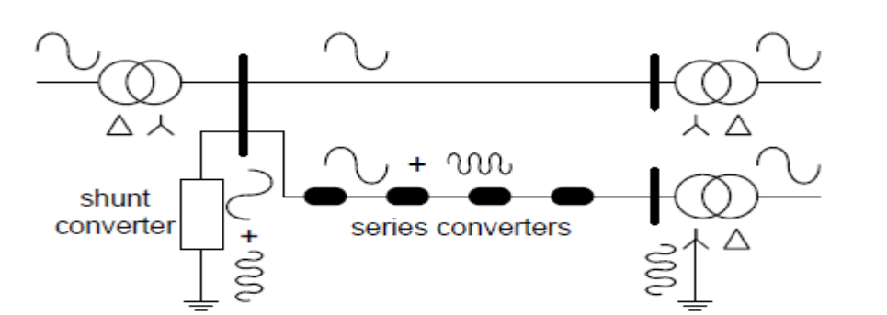
Fig.4.8. Route the harmonic current by using the grounding of the Y-∆ transformer
The relationship between the exchanged active power at the i^{th} harmonic frequency P_{i} and the voltages generated by the converters is expressed by the well known the power flow equation and given as
P_{i} = [V/(X_{i})] Sin(θ_{sh,i}-θ_{se,i}) … (4.6)
Where X_{i} is the line impedance at i^{th} frequency, V_{sh,i} and V_{se,i} are the voltage magnitudes of the i^{th} harmonic of the shunt and series converters, and θ_{sh,i}-θ_{se,i} is the angle difference between the two voltages. As shown, the impedance of the line limits the active power exchange capacity. To exchange the same amount of active power, the line with high impedance requires higher voltages. Because the transmission line impedance is mostly inductive and proportional to frequency, high transmission frequencies will cause high impedance and result in high voltage within converters. Consequently, the zero-sequence harmonic with the lowest frequency - the 3rd harmonic - has been selected.
4.9. DPFC Control
To control multiple converters, a DPFC consists of three types of controller’s central control, shunt control and series control. The shunt and series control are localized controllers and are responsible for maintaining their own converters parameters.
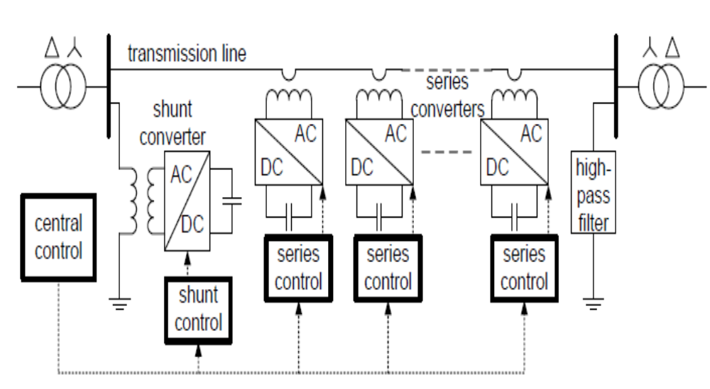
Fig.4.9. DPFC control block diagram
4.10. Central Control
The central control generates the reference signals for both the shunt and series converters of the DPFC. Its control function depends on the specifics of the DPFC application at the power system level, such as power flow control, low frequency power oscillation damping and balancing of asymmetrical components. According to the system requirements, the central control gives corresponding voltage reference signals for the series converters and reactive current signal for the shunt converter. All the reference signals generated by the central control concern the fundamental frequency components.

4.10.1. Series Control
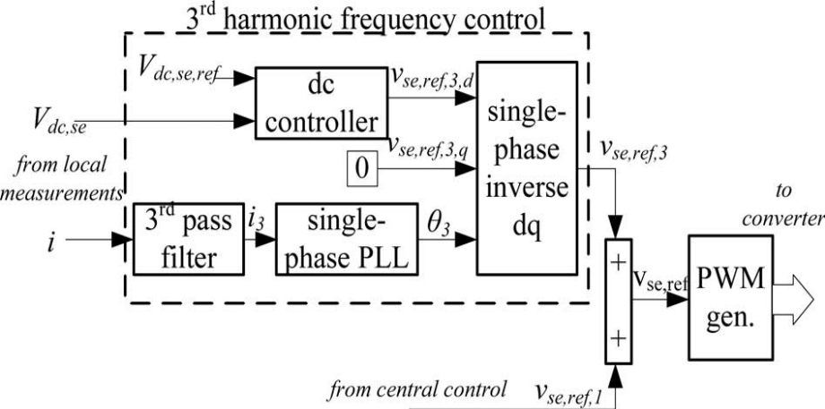
Fig.4.10. Block diagram of the series converter control
Each series converter has its own series control. The controller is used to maintain the capacitor DC voltage of its own converter, by using 3rdharmonic frequency components, in addition to generating series voltage at the fundamental frequency as required by the central control.
4.10.2. Shunt Control
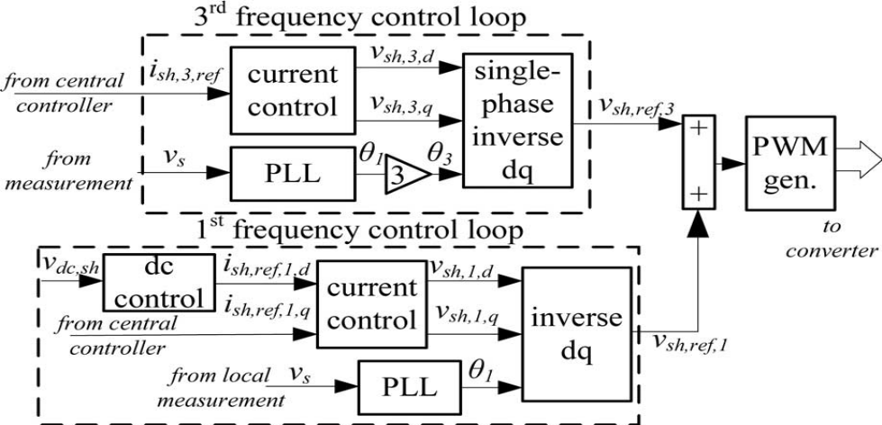

Fig.4.11. Block diagram of the shunt converter control
The objective of the shunt control is to inject a constant 3rd harmonic current into the line to supply active power for the series converters. At the same time, it maintains the capacitor DC voltage of the shunt converter at a constant value by absorbing active power from the grid at the fundamental frequency and injecting the required reactive current at the fundamental frequency into the grid. The detailed schematics and designs of the DPFC control will be introduced in following chapters.
In the DPFC, the shunt converter should be a relatively large three-phase converter that generates the voltage at the fundamental and 3rd harmonic frequency simultaneously. A conventional choice would be a three-leg, three-wire converter. However, the converter is an open circuit for the 3rd harmonic components and is therefore incapable of generating a 3rd harmonic component. Because of this, the shunt converter in a DPFC will require a different type of 3-phase converter. There are several 3-phase converter topologies that can generate 3rd harmonic frequency components, such as multi-leg, multi-wire converters or three single-phase converters these solutions normally introduce more components, thereby increasing total cost.
A new topology for the DPFC shunt converter is proposed. The topology utilizes the existing Y- transformer to inject the 3rd harmonic current into the grid. A single- phase converter is connected between the transformer’s neutral point and the ground, and injects a 3rd harmonic current into the neutral point of the transformer. This current evenly spreads into the 3-phase line through the transformer. The converter can be powered by an additional back-to-back converter connected to the low-voltage side of the transformer. For a symmetrical system, the voltage potential at the neutral point and fundamental frequency is zero. Accordingly, the single-phase converter only handles the 3rd harmonic voltages, which are much lower than the voltage at the fundamental frequency. As the single-phase converter is only used to provide active power for the series converter, the voltage and power rating are small. In addition, the single-phase converter uses the already present Y-∆ transformer as a grid connection.
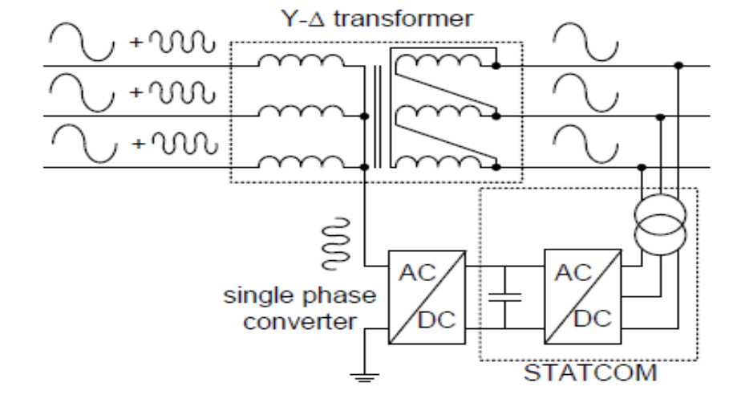
Fig.4.12. DPFC shunt converter configuration
4.11. Advantages And Limitation Of The DPFC
The DPFC can be considered a UPFC that employs the D-FACTS concept and the concept of exchanging power through the 3rd harmonic. In this way, the DPFC inherits all their advantages:
• High controllability, the DPFC can simultaneously control all the parameters of the transmission network: line impedance, transmission angle and bus voltage.
• High reliability, the redundancy of the series converter gives high reliability without increasing cost. In addition, the shunt and series converters are independent and failure of one will not influence the other converters.
• Low cost, there is no phase-to-phase voltage isolation required between the series converters of different phases. The power rating of each converter is also low. Because of the large number of the series converters, they can be manufactured in series production. If the power system is already equipped with the STATCOM, the system can be updated to the DPFC with only low additional costs.
• Extra currents, because the exchange of power between the converters takes place through the same transmission line as the main power, extra currents at the 3rd harmonic frequency are introduced. These currents reduce the capacity of the transmission line and result in extra losses within the line and the two Y-∆ transformers. However, because this extra current is at the 3rd harmonic frequency, the increase in the RMS value of the line current is not large and through the design process can be limited to less than 5% of the nominal current.
4.12. Summary
To reduce the failure rate of the components by selecting components with higher ratings than necessary or employing redundancy at the component or system levels are also options. Unfortunately, these solutions increase the initial investment necessary, negating any cost related advantages. Accordingly, new approaches are needed in order to increase reliability and reduce cost of the UPFC and IPFC at the same time. So DPFC consists more advantages than UPFC.

